SVG

📘 Definition
# Source: AI Source: Provided by: [Data Path: Persons Table -> ID Column: 1, Name_En Column: Motasem Essam] -> From: [ChatGPT] on [5/2/2026]
SVG (Scalable Vector Graphics) is a vector image format used to create graphics using shapes, lines, and mathematical formulas instead of pixels.
It is called “scalable” because it can be resized to any size without losing quality.

✏️ How SVG works
# Source: AI Source: Provided by: [Data Path: Persons Table -> ID Column: 1, Name_En Column: Motasem Essam] -> From: [ChatGPT] on [5/2/2026]
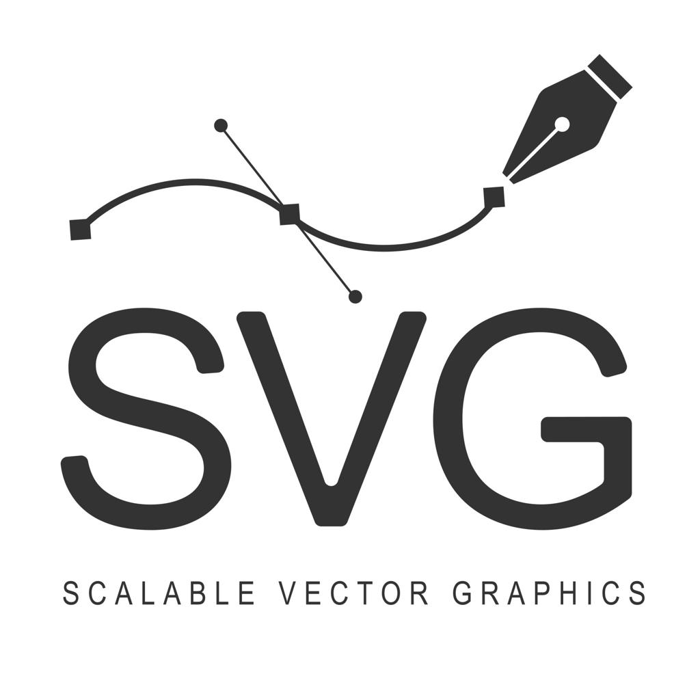
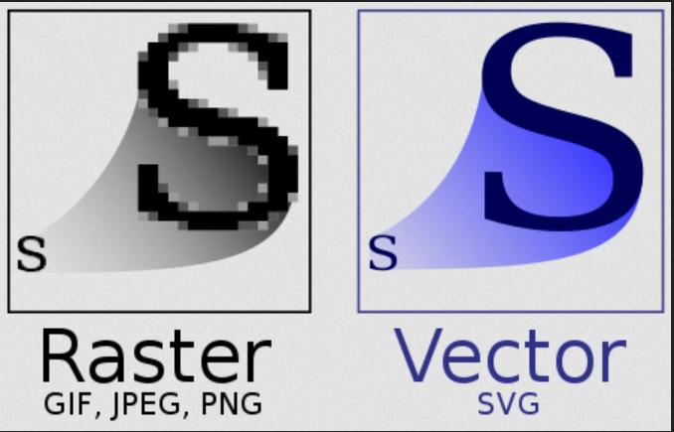
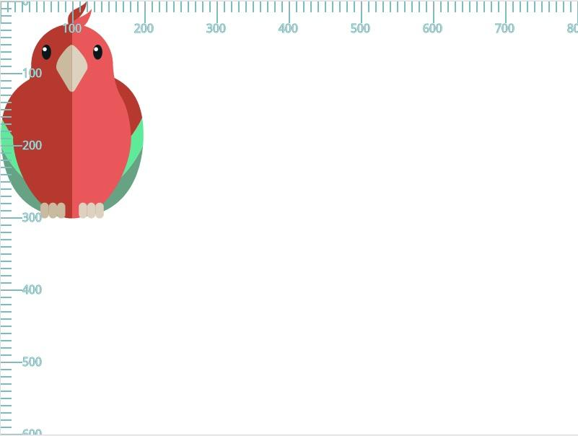
- SVG uses mathematical descriptions (paths, points, curves)
- The image is drawn by the browser or software when needed
- It does not depend on pixels
- It stays sharp at any zoom level

🧠 Simple example
# Source: AI Source: Provided by: [Data Path: Persons Table -> ID Column: 1, Name_En Column: Motasem Essam] -> From: [ChatGPT] on [5/2/2026]
Think of:
- 🔍 A logo that stays sharp when zoomed in
- 📊 Icons on websites (home, search, menu)
- 🎨 Simple illustrations or diagrams
Even if you zoom in a lot, it never becomes blurry.

🌐 Where SVG is used
# Source: AI Source: Provided by: [Data Path: Persons Table -> ID Column: 1, Name_En Column: Motasem Essam] -> From: [ChatGPT] on [5/2/2026]
- 🌐 Web design (icons, logos, UI elements)
- 🎨 Graphic design
- 📊 Data charts and diagrams
- 📱 App interfaces

⚙️ Key features
# Source: AI Source: Provided by: [Data Path: Persons Table -> ID Column: 1, Name_En Column: Motasem Essam] -> From: [ChatGPT] on [5/2/2026]
- 📐 Based on vectors (not pixels)
- 🔍 Scalable without quality loss
- 🧩 Lightweight and editable
- 💻 Often written in XML/code format

🚀 In short:
# Source: AI Source: Provided by: [Data Path: Persons Table -> ID Column: 1, Name_En Column: Motasem Essam] -> From: [ChatGPT] on [5/2/2026]
SVG = a vector image format that uses mathematical shapes to create graphics that stay sharp at any size.

